PEBB Flu Shots
Date(s):
Time(s):
Location:

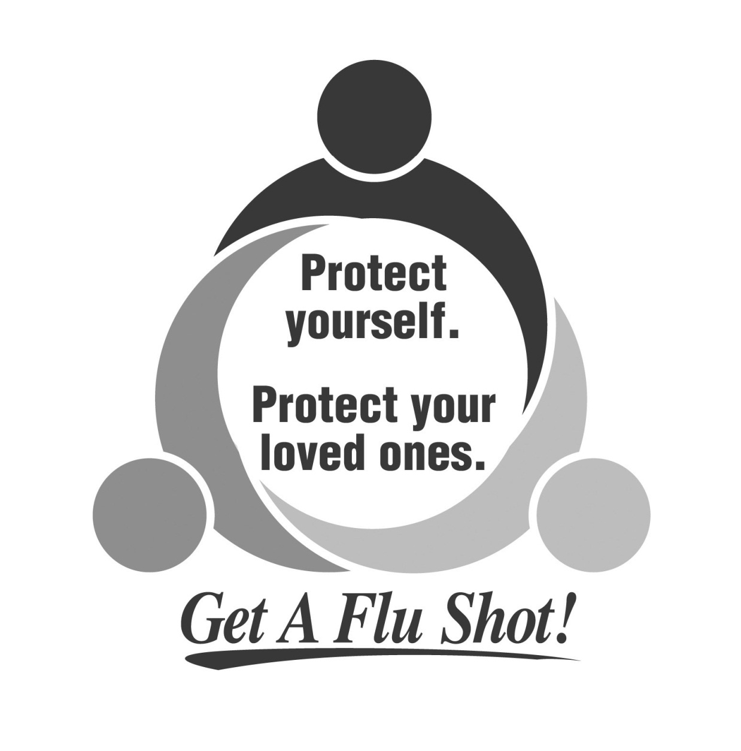

Contact Name & #
Remember to wear short sleeves or layered clothing on flu shot day.
All immunizations administered by licensed nurse.
Service by GetAFluShot.com

